**LAB SESSION 12**

**PREPARED BY: MUHAMMAD FARAZ ANSAR (SE-061)**

* **RING COUNTER**

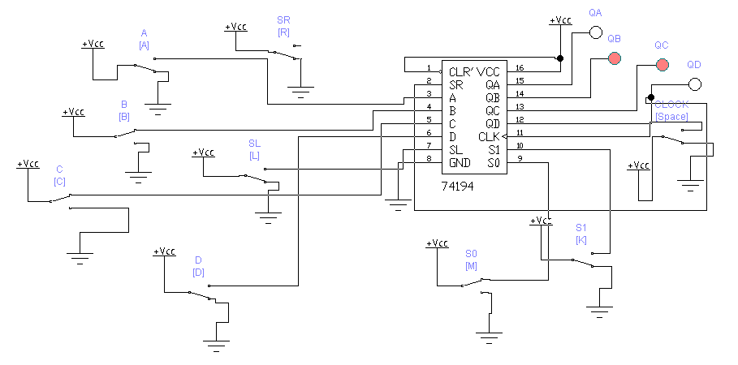

* **SHIFT REGISTER**

